A
PROJECT REPORT
ON

“Online Furniture Shop”

BY
KUNDAN TANAJI PISE
Seat No- 21474
MCA- II SEM-IV

SAVITRIBAI PHULE PUNE UNIVERSITY

In Partial Fulfillment of
MASTER OF COMPUTER APPLICATIONS

SINHGAD INSTITUTE OF BUSINESS ADMINISTRATION AND RESEARCH
Kondhwa (Bk.), Pune-411048
2021-2022

CERTIFICATE OF ORIGINALITY

This is to certify that the project report entitled Online Furniture Shop. Submitted to the Department of Computer Applications, Sinhgad Institute of Business Administration and Research in partial fulfillment of the requirement for the award of the degree of MASTER OF COMPUTER APPLICATIONS (MCA Affiliated to Savitribai Phule Pune University), is an original work carried out by
Mr.Kundan Tanaji Pise
Exam No. 21474
under my guidance.

The matter embodied in this project is a genuine work done by the student and has not been submitted whether to this Organization or to any other University/ Organization for the fulfillment of the requirement of any course of study.

Signature of the Student :
Name of the student : Kundan Tanaji Pise
Signature of the Guide :
Name and Designation of the Guide : Prof. Pramodini Dange
Dr. Netra Patil :
Signature of Director-MCA

Date :

CERTIFICATE OF APPROVAL

This is to certify that the project report entitled Online Furniture Shop. submitted to the Department of Computer Applications, Sinhgad Institute of Business Administration and Research in partial fulfillment of the requirement for the award of Degree of MASTER OF COMPUTER APPLICATIONS (MCA Affiliated to Savitribai Phule Pune University) is an original work carried out by
Mr. Kundan Tanaji Pise
Exam No. 21474

The matter embodied in this project is a genuine work done by the student and has been certified by the following internal and external examiners deputed by Savitribai Phule Pune University.

Internal Examiner External Examiner

INDEX
Sr. No |  | Contents
1 |  | INTRODUCTION
 | 1.1 | About System
 | 1.2 | Existing System and Need For Syatem:
 | 1.3 | Scope of Work
 | 1.4 | Operating Environment – Hardware and Software
2 |  | PROPOSED SYSTEM
 | 2.1 | Proposed System
 | 2.2 | Feasibility Study
 |  | Technical Feasibility
 |  | Economics Feasibility
 |  | Operational Feasibility
 | 2.3 | Objectives of System
3 |  | ANALYSIS AND DESIGN
 | 3.1 | Entity Relationship Diagram (ERD)
 | 3.2 | Use Case Diagrams
 | 3.3 | Class Diagram
 | 3.4 | Activity Diagram
 | 3.5 | Sequence
 | 3.6 | Modules
 | 3.7 | Sample Input and Output Screens
4 |  | Table Structure
5 |  | Database Records
6 |  | Drawbacks and Limitations
7 |  | Bibliography

1 ] INTRODUCTION

1.1] About System :

It is an online furniture shop that allows users to check for various furniture
available at the online store and purchase online. The project consists of list of furniture
products displayed in various models and designs. The user may browse through these
products as per categories. If the user likes a product he may add it to his shopping cart. Once user wishes to checkout he must register on the site first. He/she can then login using same id password next time. User can select any payment option that he wish to like credit card, debit card or cash on delivery. Once the user makes successful transaction he gets a copy of the shopping receipt on his email id. Here we use. The online furniture shopping project brings an entire furniture shop online and makes it easy for both buyer and seller to make furniture deals.

1.2] Existing System and Need For Syatem:

In existing system Furniture shopping can done in a manual way, the customer has to go for shopping, and then he is having the possibility to choose the products whatever he wants.

It is a time consuming process.

Thus, the system has to be automated.

In Existing System the Customer is completely depending on the manual process for buying the Furniture products.

Manual process is a time consuming factor. And when customer approaches for a manual shopping directly, actually he/she does not have an idea about things like, price range, items,
etc.,

The time which has been spent by the customer in manual shopping can equates to multiple number of shopping. As customer can sit at home and browse in a fraction of seconds.

Thus we need to change to a system like "Online Furniture Shopping "

1.3] Scope of Work :

This system can be implemented to any shop in the locality or to multinational branded shops having retail outlet chains. The system recommends a facility to accept the orders 24*7 and a home delivery system which can make customers happy. Customers can also manage their shopping cart by adding and removing the items. If shops are providing an online portal where their customers can enjoy easy shopping from anywhere, the shops won’t be losing any more customers to the trending online shops such as flipcart or ebay. Since the application is available in the smartphone it is easily accessible and always available.

1.4] Operating Environment

A ] Hardware Requirements:

- Processor:- Intel Pentium 4 or above
- Memory:- 2GB or above
- Hard Disk:- (Minimum) 40GB

B] Software Requirements :

- Technology used:- HTML,CSS,JS,BOOTSTRAP
- Database Server:- PHP,MY-SQL
- Operating System:- Windows 10
- Browser/Framework:- Google Chrome

2] PROPOSED SYSTEM

2.1] Proposed System

“Online Furniture Shop” is a web based application. The main aim of this project is to established on online furniture shop system which allows the user to buy the furniture online. User can make online payment through credit card and debit card. But this present generation which has money but lack of time can’t go to the furniture shop to buy furniture. It is tedious and time consuming process.
By keeping these point in mind we have develop this online furniture portal. This project will be very much helpful for the present generation which runs shortage of time . customer to browse through the shop and purchase them online without having to visit the shop physically. Now they can obtain their desire furniture without leaving the comfort of their home. They can also place the order of their desire design making their life more comfortable and luxurious.

2.1.1] Feasibility Study

“ Feasibility Study under taken to determined possibility of either improving the existing system developing completely new system . It helps to often and overview from the problem and get rough ideas and the whether feasible solution exits “.
There are Three types of feasibility study :
A ] Technical Feasibility
B ] Economical Feasibility
C ] Operational Feasibility

2.1.1.A.] Technical Feasibility

This feasibility determines whether it is possible to develop the project with available software technology and the manpower.
The work of the System can be carried out with Intel Core 2 Duo CPU , 256 GB HDD, 4 GB RAM, PHP,HTML,CSS,JS,BOOSTRAP. User of the system should have no required software knowledge. They have to be technically trained before this system is implemented .The system is Hardware & Software efficient, Hence is technically feasible .

2.1.1.B] Economical Feasibility

In this the benefit of the system are considered. Actually the cost benefit analysis is done. The cost must include both one time costs and recurring costs.
System is developed in php, html, css, js, boostrap, which are open source technology, can be easily available. Potential users can easily arrange for the system requirements. The system is time & cost efficient and hence is economically feasible.

2.1.1.C] Operational Feasibility

System is developed in php, html, css, js, boostrap it’s facilitating long term benefits . It requires knowledge on part of the user to handle the system .The system is user friendly and interactive with provision of appropriate and effective messages. Any person can handle this system easily hence it is operational feasible .

2.2] Objectives of System

This proposed system is computerized system and it improves the performance of the system.

- The System is developed in manner that it is user friendly
And required validation are provided at different
level.

- It helps customer to find different type of furniture.

- The system is easy to handle.

- To facility easy retrieval of data & information.

- Data should be remaining secured even on system crash.

- To enhance speed of work.

3]ANALYSIS AND DESIGN

3.1] ER Diagram:-

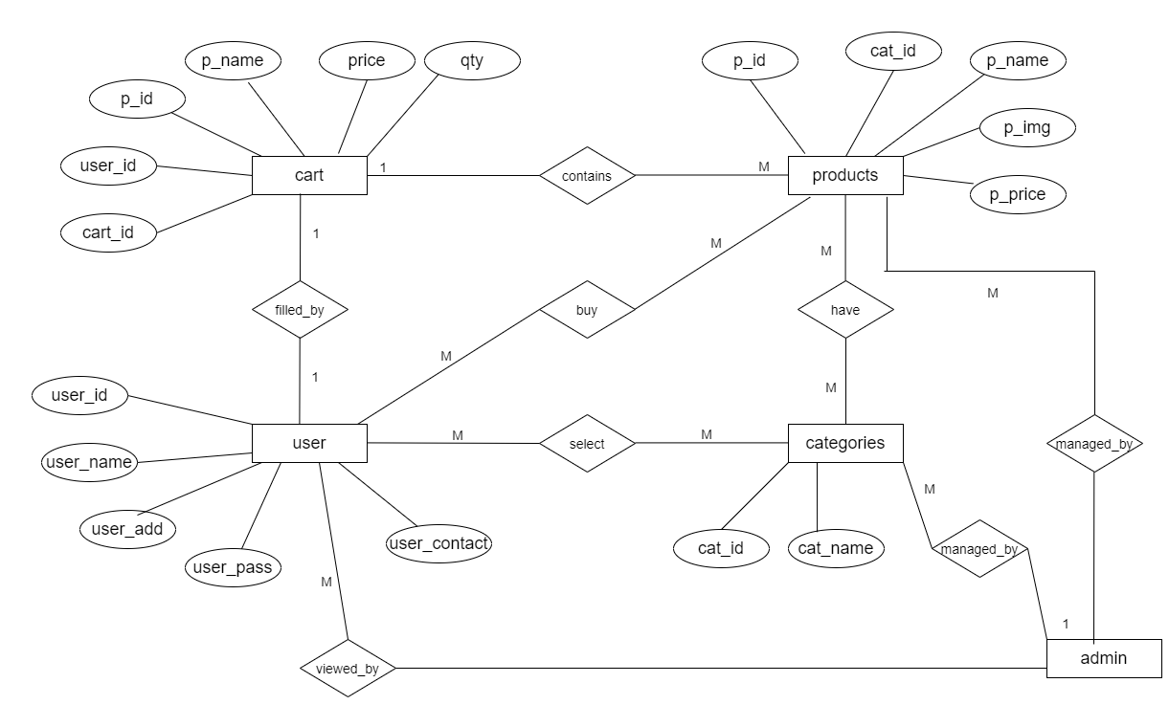

3.2] Use Case Diagram:-

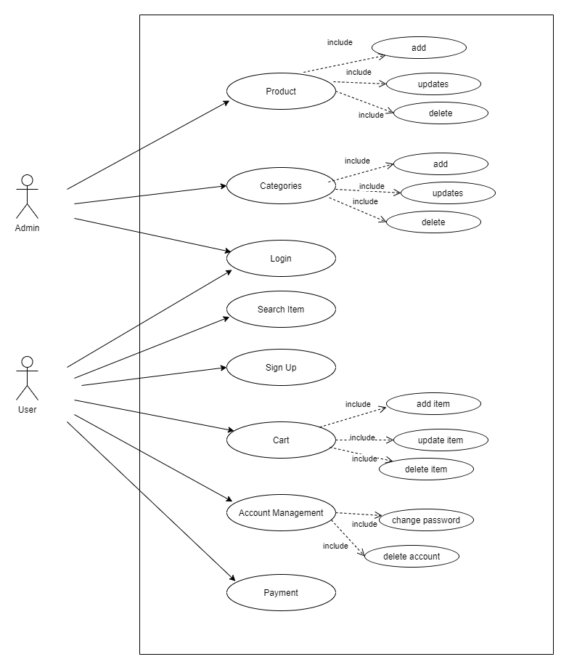

3.3] Class Diagram:-

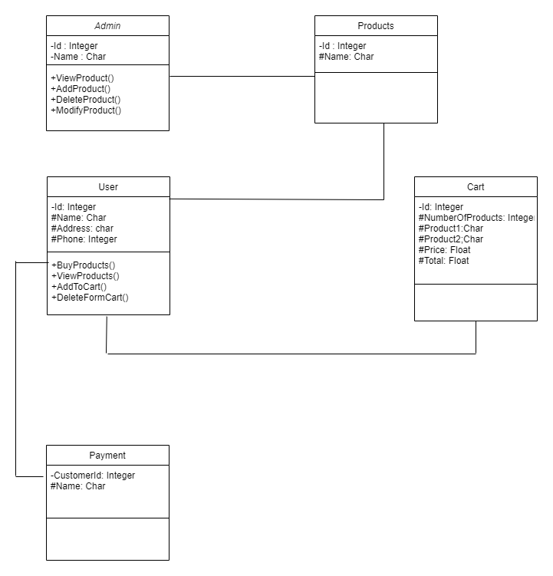

3.4] Activity Diagram:-

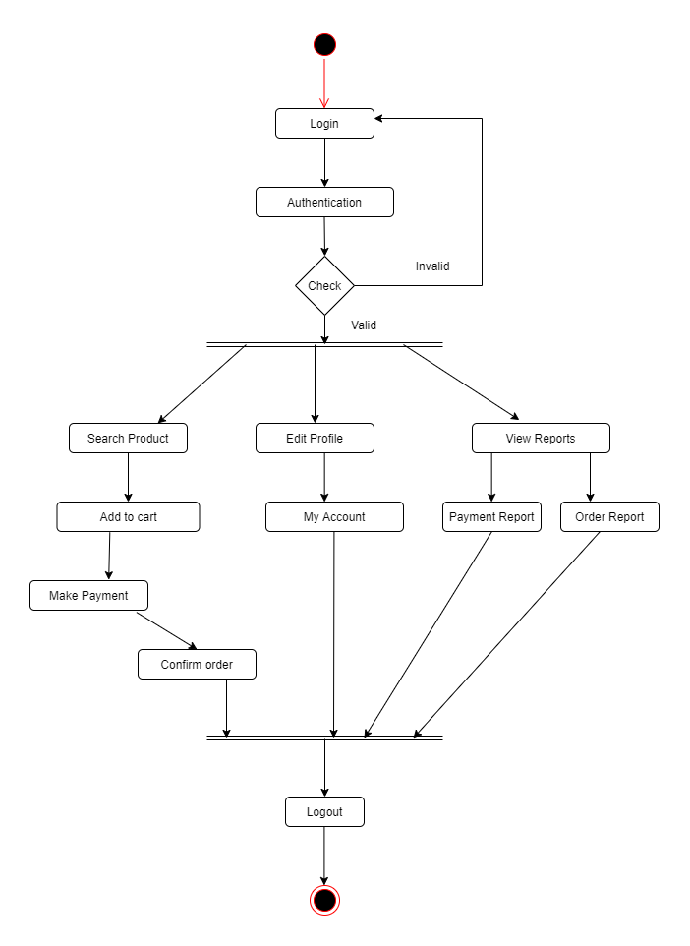

3.5] Sequence Diagram:-

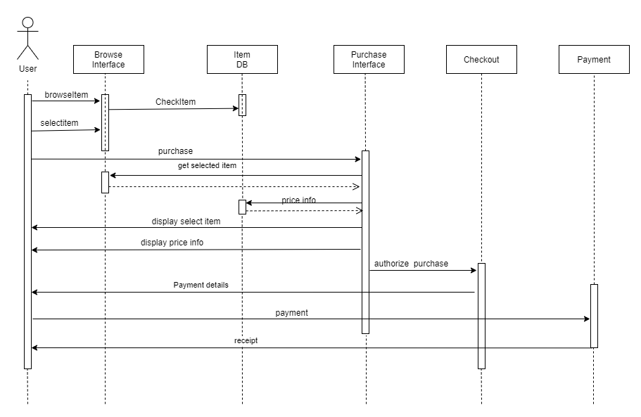

3.6] Modules :-

Admin Module:-

- Admin Login
- Admin Dashboard
- Products
- Add,Delete,Edit Products
- Users
- Orders
- Reports

User Module:-
- Homepage
- Products
- Login
- Register
- Add Cart
- Billing
- Logout

3.7 ] Sample Input and Output Screens

ANNEXURE 1 : SCREEN DESIGN

Home Screen:-

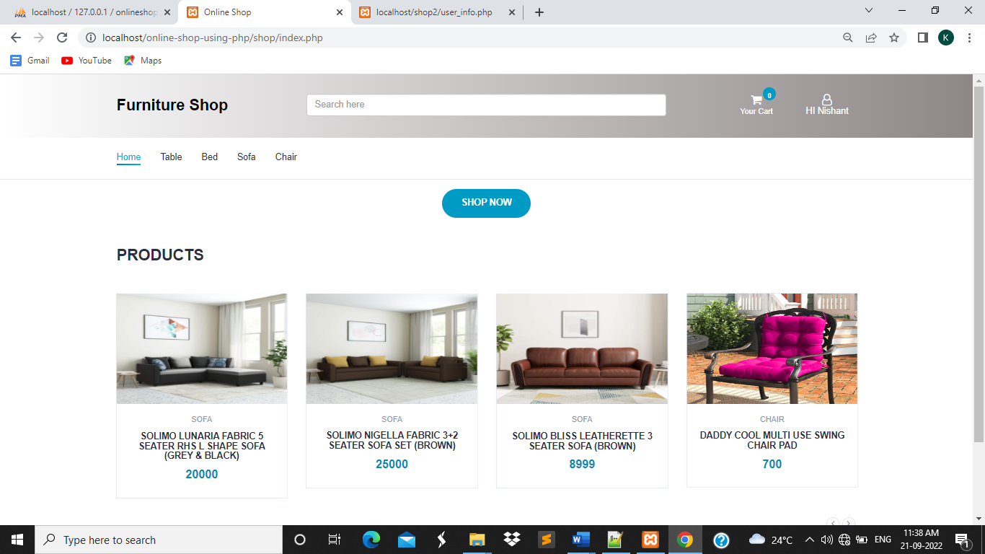

Products screen:-

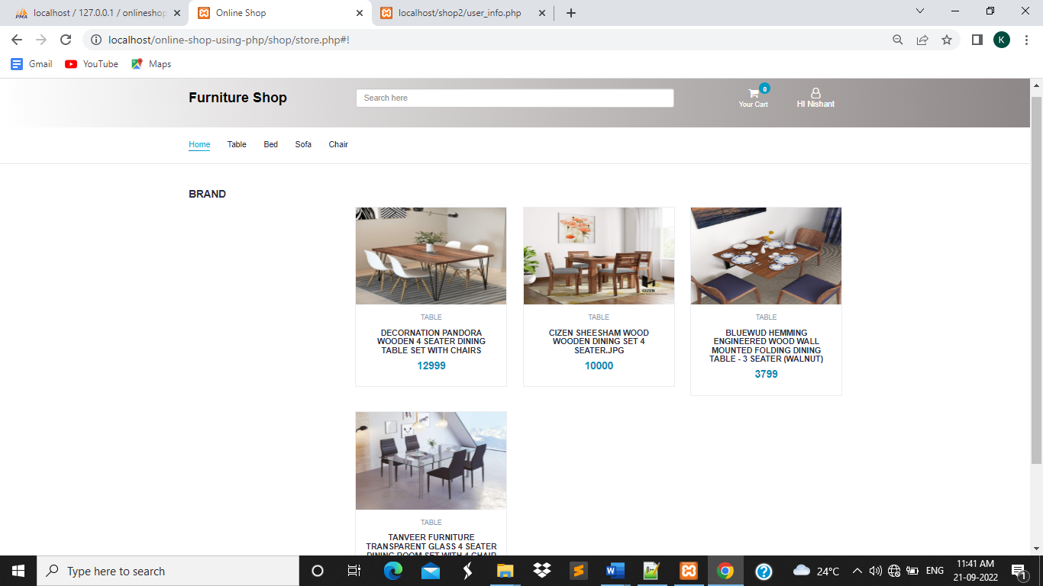

Login Screen:-

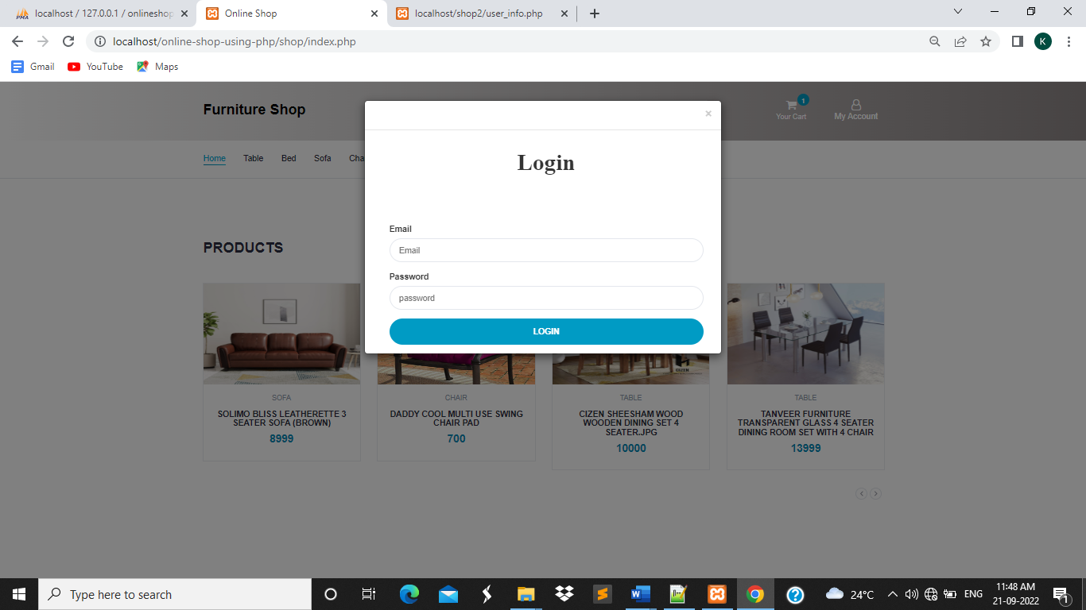

Register Screen:-

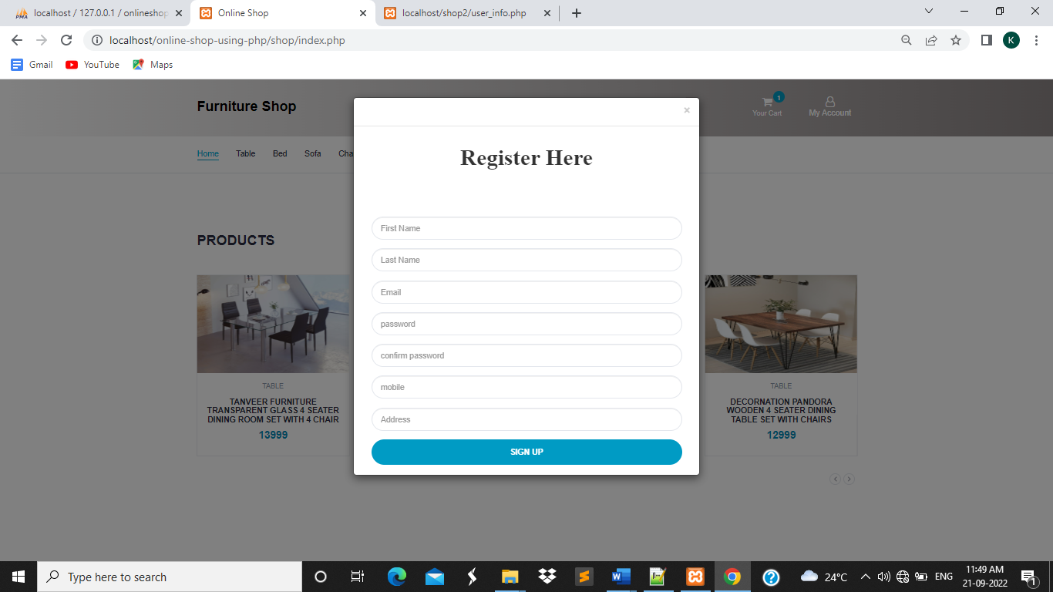

Cart Screen:-

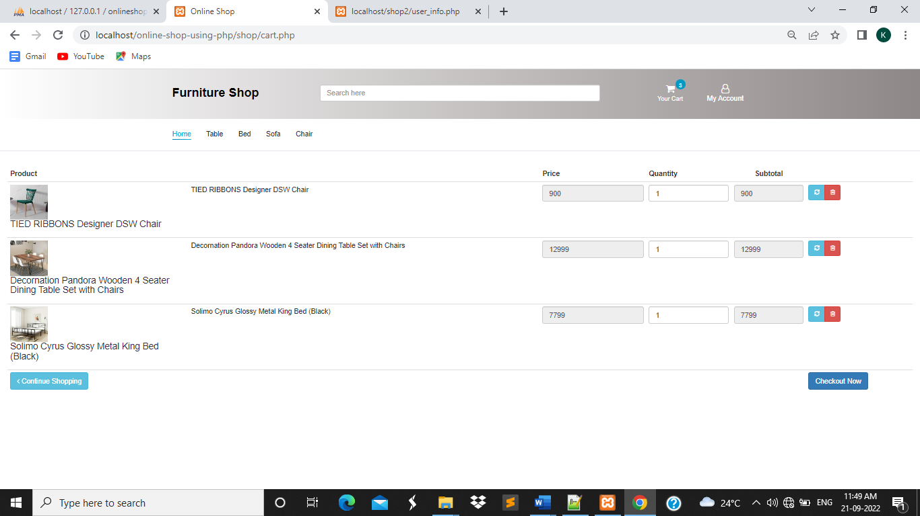

Payment Screen:-

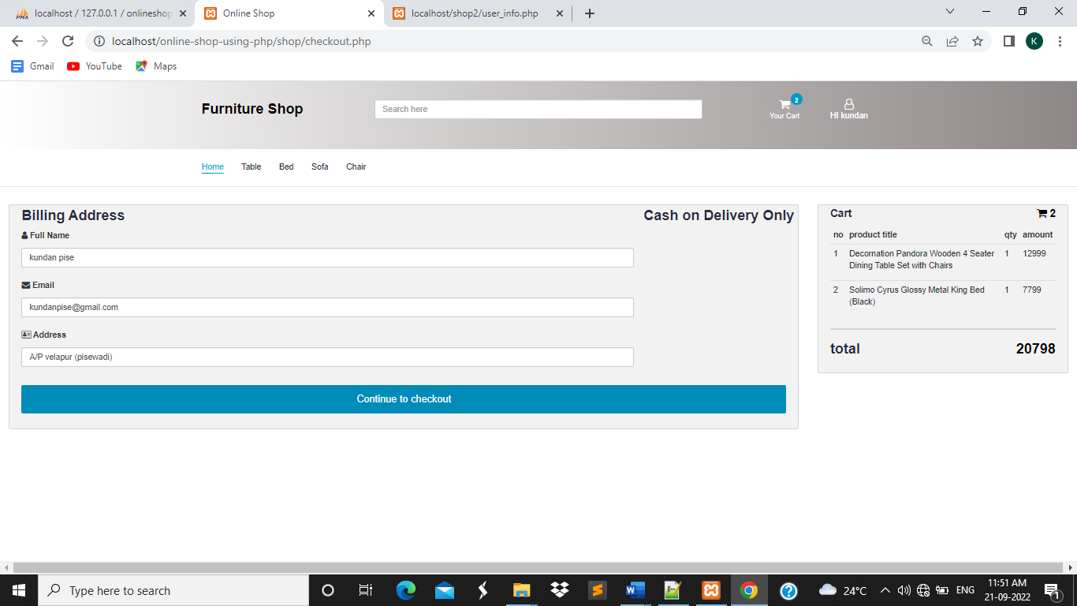

Logout:-

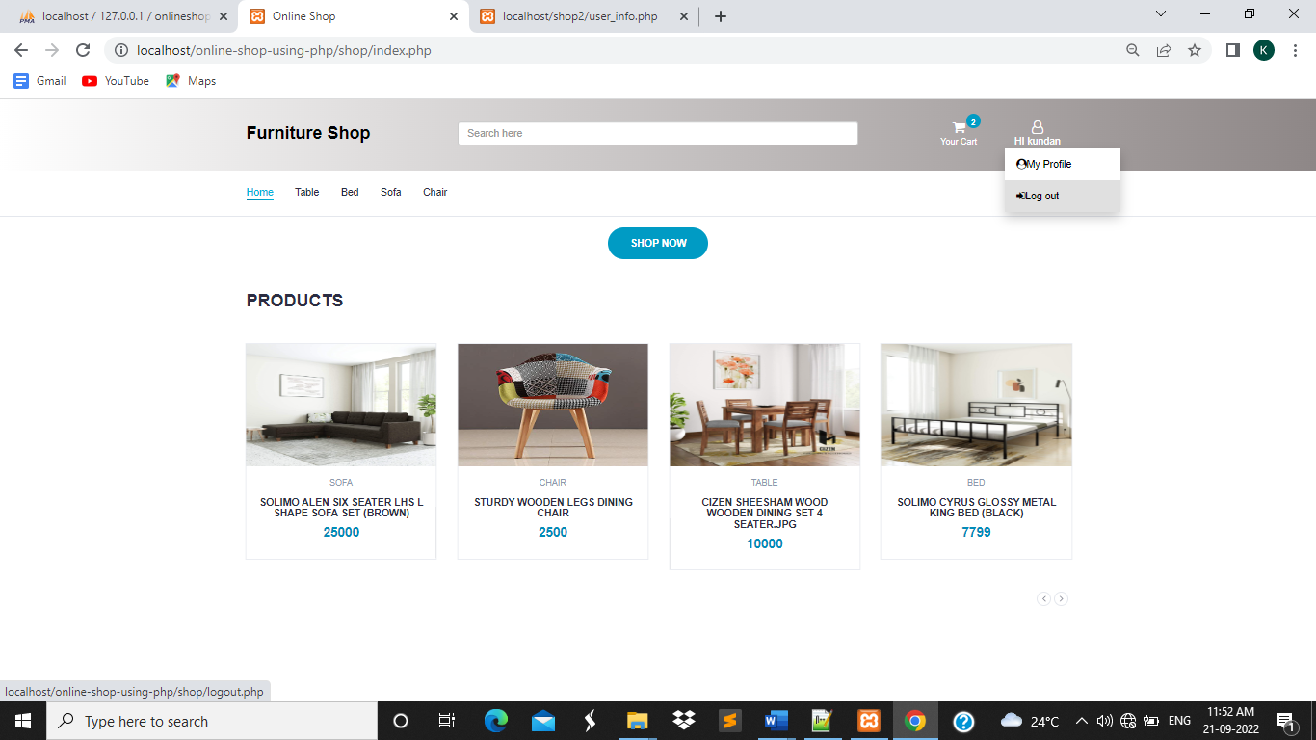

Admin:-
Admin login:-

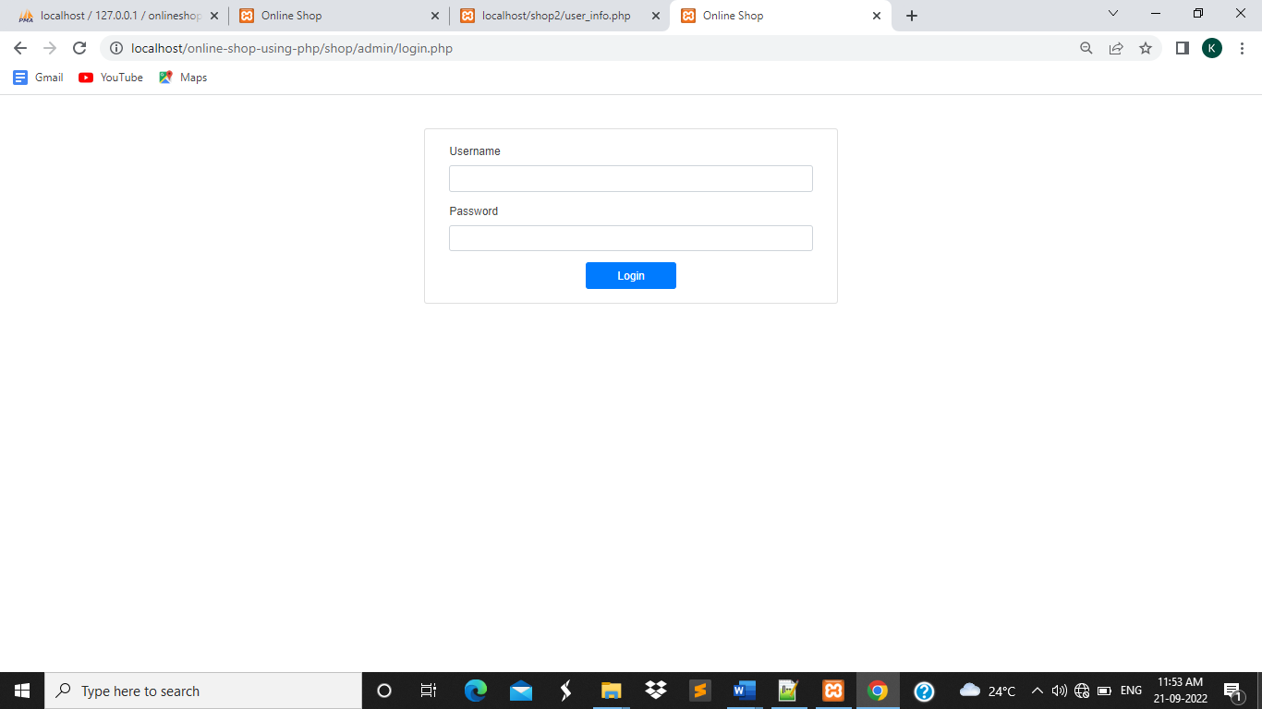

Admin Home:-

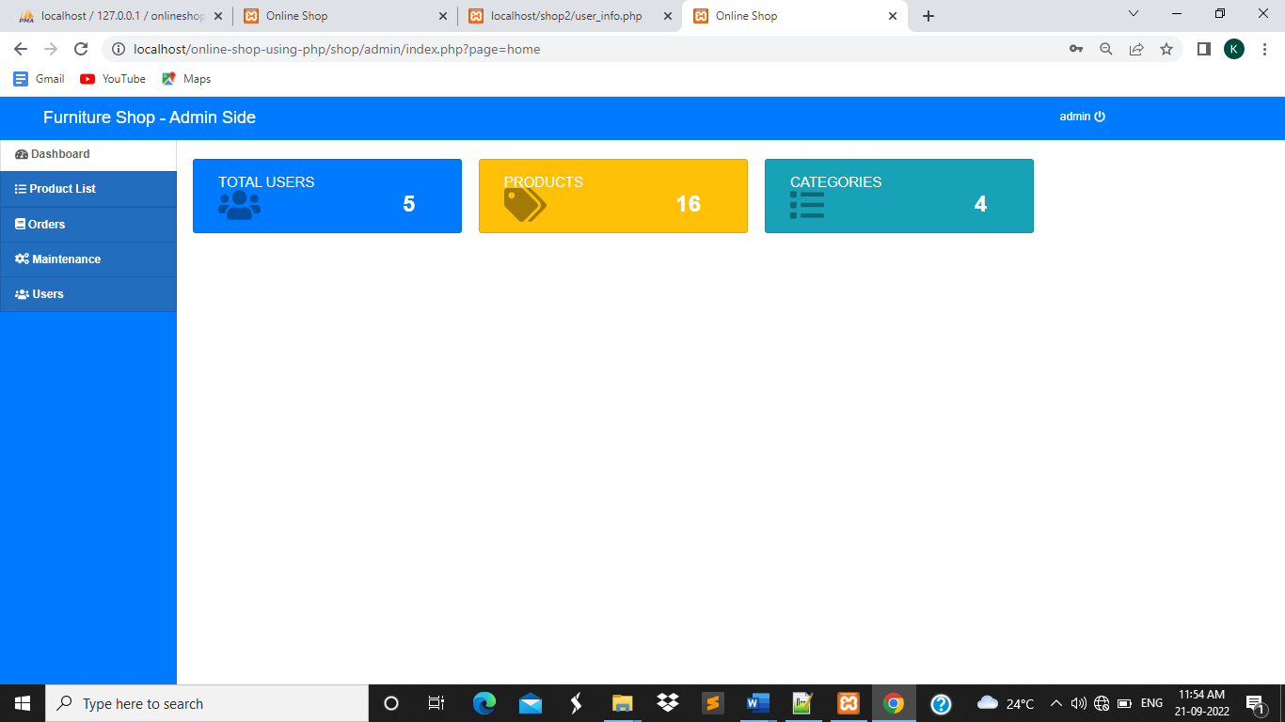

Add-Product Screen-

Product-List:-

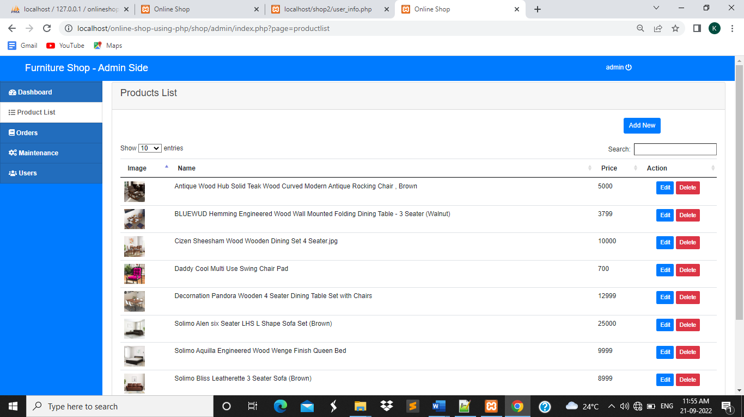

Add-Categories:-

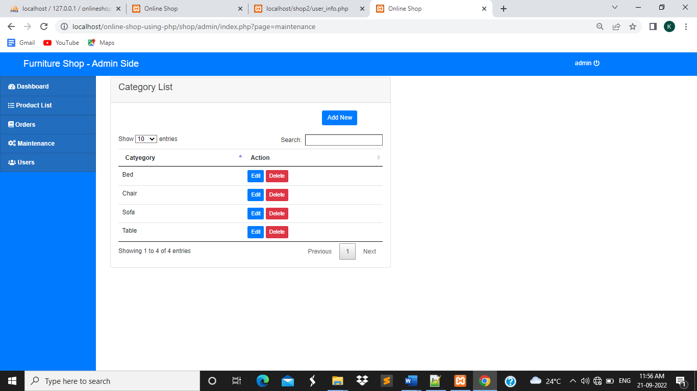

Orders Info:-

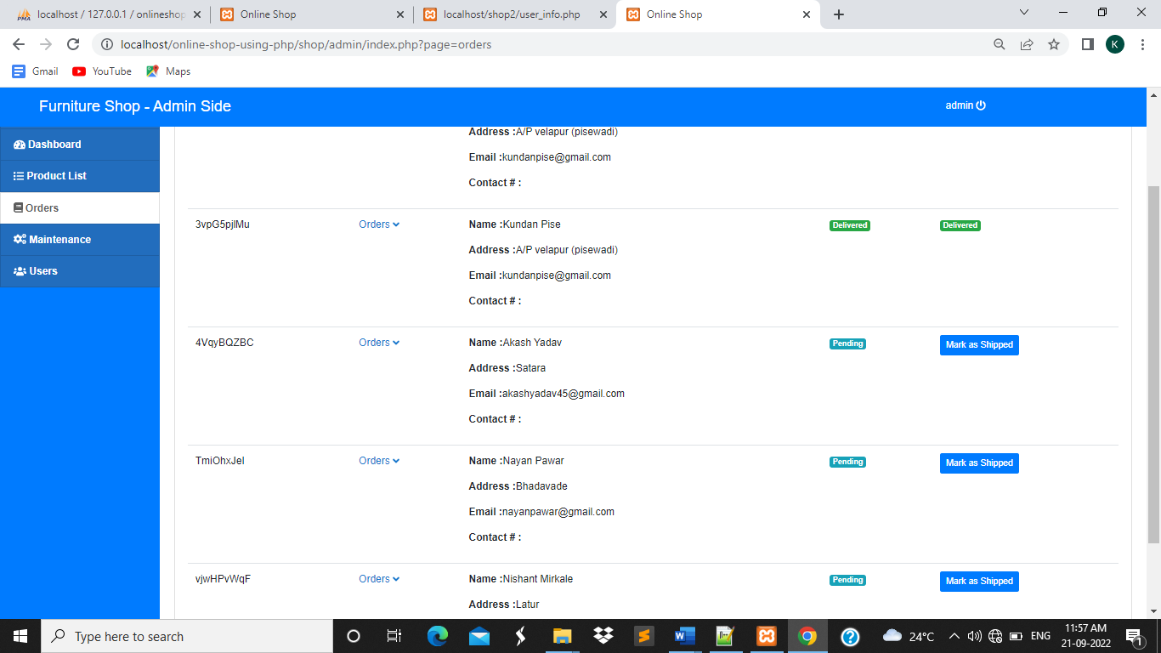

Users Info:-

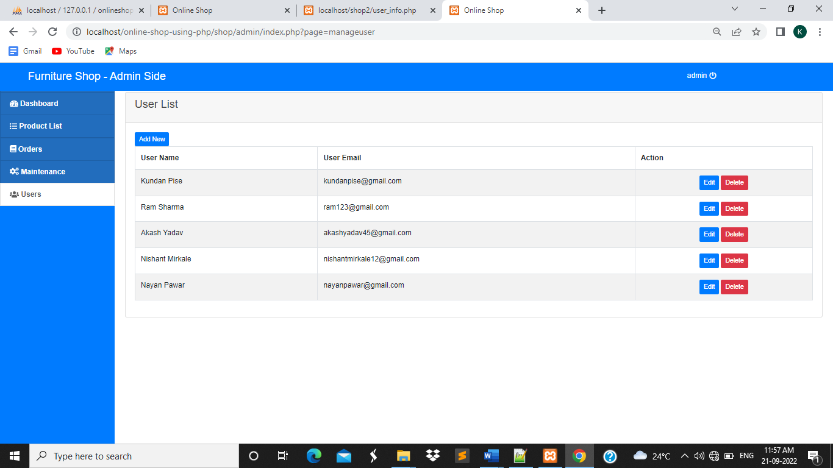

4] Table Structure

FILE DESIGN

- TABLE FOR ADMIN LOGIN.

This table stores total information about the admin login.

NO | FIELD NAME | DATA TYPE | SIZE | CONSTRAINT
1 | Admin_id | INT | 10 | Primary Key
2 | Admin_name | VARCHAR | 10
3 | username | VARCHAR | 10
4 | password | VARCHAR | 20

- TABLE FOR USER DETAILS

This table stores total information about the customer.
NO | FIELD NAME | DATA TYPE | SIZE | CONSTRAINT
1 | User_id | INT | 10 | Primary Key
2 | First_Name | VARCHAR | 20
3 | Last_Name | VARCHAR | 20
4 | Email | VARCHAR | 20
5 | Password | VARCHAR | 10
6 | Contact No | INT | 10
7 | Address | VARCHAR | 30

- TABLE FOR PRODUCT DETAILS

This table stores total information about the Products.

NO | FIELD NAME | DATA TYPE | SIZE | CONSTRAINT
1 | Product_id | INT | 10 | Primary Key
2 | Product_Cat | VARCHAR | 15
3 | Product_Brand | VARCHAR | 10
4 | Product_Title | VARCHAR | 10
5 | Product_Price | VARCHAR | 10
6 | Product_Desc | INT | 10
7 | Product_Image | TEXT | 20

- TABLE FOR ORDERS INFORMATION

This table stores total information about orders.

NO | FIELD NAME | DATA TYPE | SIZE | CONSTRAINT
1 | Order_id | INT | 10 | Primary Key
2 | User_id | VARCHAR | 10 | Foreign Key
3 | First_name | INT | 10
4 | Email | DATE
5 | Address | DATE
6 | City | VARCHAR | 10
7 | State | VARCHAR | 20
8 | Prod_count | INT | 20
9 | Total_amt | FLOAT | 20

- TABLE FOR CATEGORIES INFORMATION

This table stores total information about Categories.
NO | FIELD NAME | DATA TYPE | SIZE | CONSTRAINT
1 | Cat_id | INT | 10 | Primary Key
2 | Cat_Title | Text | 30

- TABLE FOR CART INFORMATION

This table stores total information about Cart.

NO | FIELD NAME | DATA TYPE | SIZE | CONSTRAINT
1 | id | INT | 10 | Primary Key
2 | Product_id | INT | 30
3 | User_id | INT | 30
4 | Qty | INT | 30

5] Database Records

Users Records:-

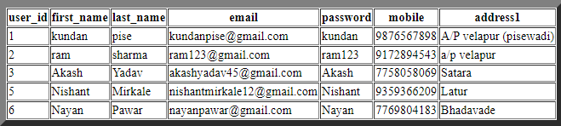

Product Records:-

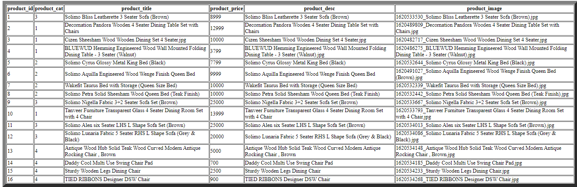

Cart Records:-

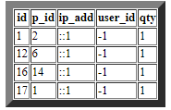

Categories Records:-

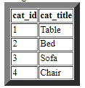

Order-Info Records :-

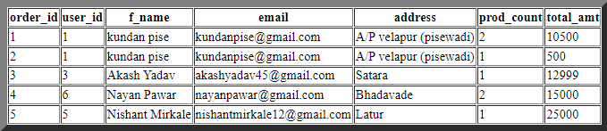

6 ] Drawbacks and Limitations

Every work/process/activity is always surrounded by some limitation, which may be caused either by nature or by human originated activities. This project report is not the exception one. During the collection data for the preparation of this report, research face many problem there are stated as under-

L As it is totally manual the major fault is to keep the registers safe.

L As well as when report is needed it is hard to get report,
Because each detail is not available at the required time.

L The limitation of this report is lack of perfection due to lack of
experience of researcher.

☹ The next limitation that he faces was limited time.

7 ] Bibliography

References:

Our project is Online Furniture Shop in php,html,css,js,bootstrap for development this system we referred the books.

www.google.com

Thank You…

